**Econometrics Analysis**

a.

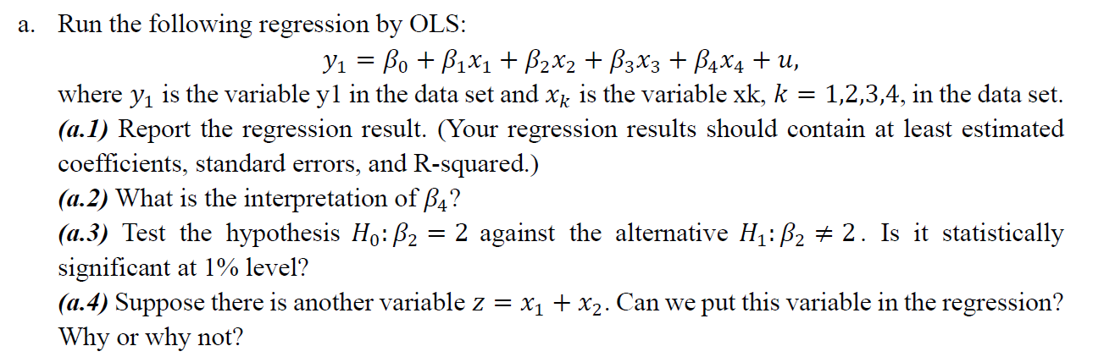

a.1

Regression Result:



a.2 Interpretation of β4: The slope coefficient is positive, so we can say that the relationship between the independent variable and the dependent variable is positive i.e., x4 and y1.

On the other side, the slope, β4 = 3.7798, implies that for each increase of 1 unit in x4, the value of y1 is estimated to increases by 3.7798 units.

a.3 Testing Hypothesis:

Set up the Hypothesis:

Null Hypothesis (H0): β2 = 2

Alternative Hypothesis (H1): β2≠2.



Rejection Region: Reject H0 if t > 1.967

Test statistic: t = 18.78

p-value is 0.0000

So, based on the above result, it can be concluded that the null hypothesis can be reject, and in favour of alternative hypothesis as the p-value is less than the level of significance i.e., 0.000 < 0.05.

On the other hand, t = 18.78 > 1.967, reject H0.

Thus, there is enough evidence to infer that the mean of x2 is significantly not equals to 2.

a.4

It not a good idea to put z = x1 + x2, because if we put this calculated variable then we need to deal with the problem of multicollinearity and the result of the regression misbehaves.

Therefore, when independent variables are correlated, it indicates that changes in one variable are associated with shifts in another variable. The stronger the correlation, the more difficult it is to change one variable without changing another. It becomes difficult for the model to estimate the relationship between each independent variable and the dependent variable independently because the independent variables tend to change in unison.

Here is the regression result after putting z into the model.



After run the regression, it is not able to estimate the p-value of the x2 and x3.

b.

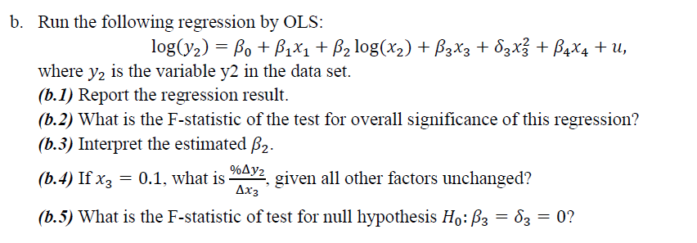

b.1

Regression result:



b.2 The overall F-statistic value is close to 0.0000, so we can say that the value is less than the 0.05 which means that the model is statistically significant.

On the other hand, if significance value is less than the F-test statistic value then model is statistically significant.

b.3 Interpretation: the slope coefficient of β2 = 0.2513, implies that for each increase of 1% unit in x2, the value of y2 is estimated to increases by 0.2513% of units.

b.4

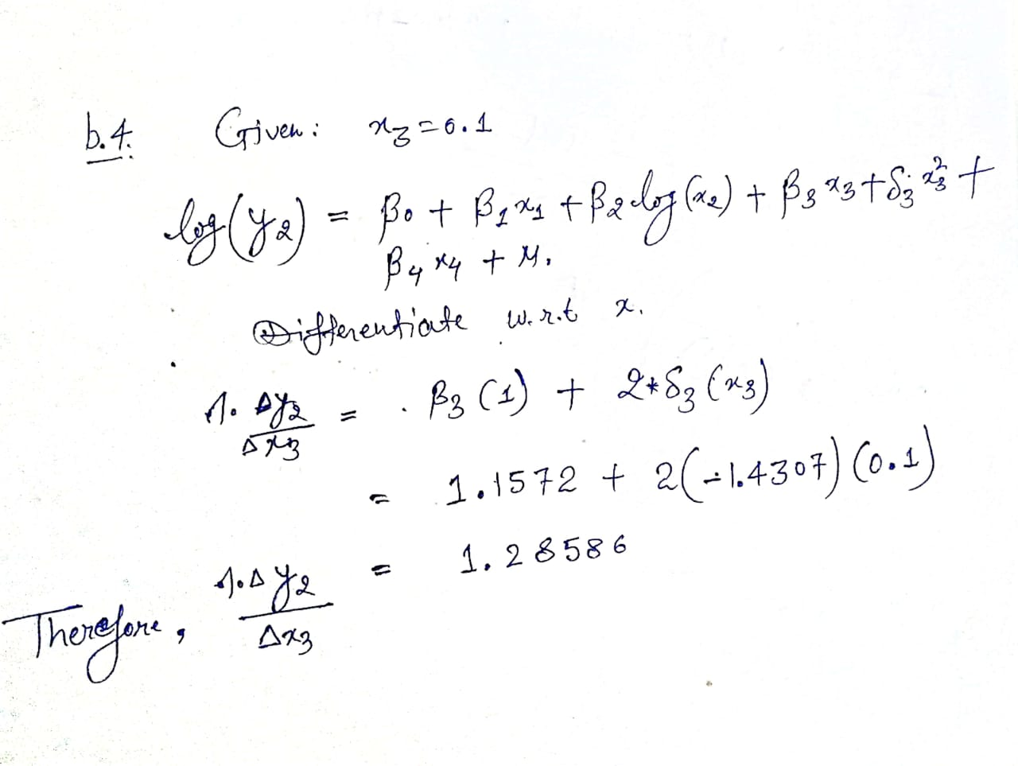

b.5

Null Hypothesis (𝐻0): 𝛽3 = 𝛿3 = 0

Alternative Hypothesis (𝐻1): one or more are wrong.

Unrestricted Model:

log(𝑦2) = 𝛽0 + 𝛽1𝑥1 + 𝛽2 log(𝑥2) + 𝛽3𝑥3 + 𝛿3𝑥23 + 𝛽4𝑥4+ 𝑢

Restricted Model:

log(𝑦2) = 𝛽0 + 𝛽1𝑥1 + 𝛽2 log(𝑥2) + 𝛽4𝑥4+ 𝑢

Regression result for restricted model is shown below:



The F-statistics formula is shown below

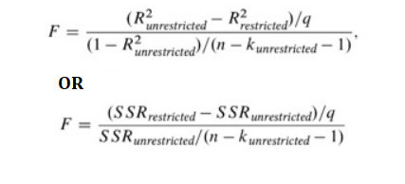

Now, putting the values on the right place:

F = $\frac{(0.3595 – 0.3411)/2}{(1-0.3595)/(300-6-1)}$

F = $\frac{(0.3595 – 0.3411)/2}{(1-0.3595)/(193)}$

F = 2.7722

Thus, the value of the test statistic is F = 2.7722 and the critical value for a 5% test with (2,193) degrees of freedom is 3.0427.

Hence, the calculated value is more than the tabulated value (or critical value), it can be concluded that we accept the null hypothesis since 2.7722 < 3.0427.

c.

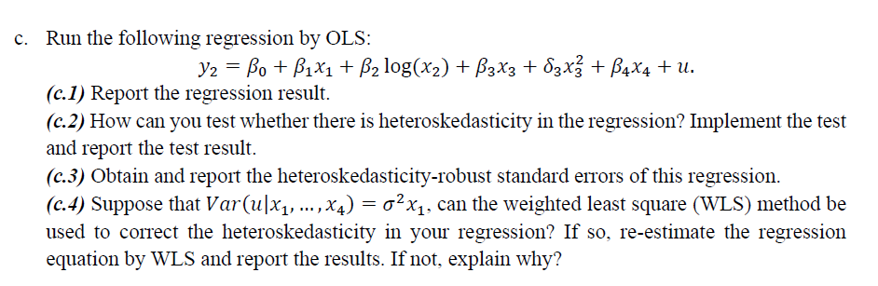

c.1

Regression result:



c.2 Testing Heteroskedasticity using residuals square of the original regression.



Null Hypothesis: Homoskedasticity (error variance are equal)

Alternative Hypothesis: Heteroskedasticity (error variance are not equal)

|  |  |
| --- | --- |
| Observed Chi-Square Value: | 4.379126512 |
| DF = K-1 | 5 |
| Critical Value | 11.07 |
| Significance Level | 0.05 |

Thus, based on the above statistics, the calculated value is less than the tabulated value (or critical value), it can be concluded that we do not reject the null hypothesis since 4.379 < 11.07.

Hence, there is a Heteroskedasticity in the model.

c.3 Heteroskedasticity-robust standard errors.

Stata command: regress y2 x1 log(x2) x3 (𝛿x3)^2 x4, vce(robust)

If you run this command, you will get an expected output. Note that use excel sheet Data_c.

Heteroskedasticity-robust standard errors:

x1 | .0262264

x2 | .0096733

x3 | .0096733

x23 | .0127093

x4 | .0096733

_cons | .1150674

c.4

WLS standard errors:

x1 | .0213123

x2 | .0114296

x3 | .0114296

x23 | .0150338

x4 | .0114296

_cons | .1459885

The weighted least square (WLS) method can be used to correct the heteroskedasticity in the regression. To re-estimate the regression equation by WLS, one can use the following command in STATA:

regress y2 x1 x2 x3 x23 x4, vce(robust) wt(x4)